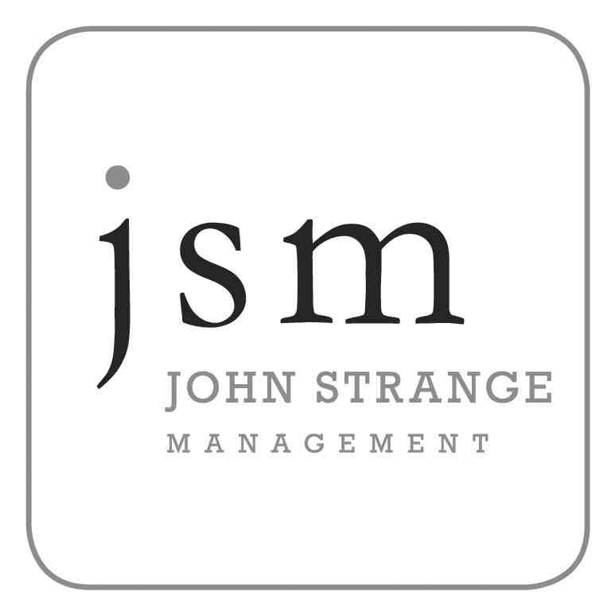
Amanda Gilliland

D.O.B: 01/08/73
Height: 5’ 4”
Eyes: Dark Brown
Hair: Brown
Build: Slim
Spotlight: 1917

Film Includes:

Joanne in Orphans Dir: Peter Mullan
Bobby’s Girlfriend in Small Faces Dir: Gillies MacKinnnon BBC Scotland

Television Includes:

Bride in SCOTTISH CUP FINAL PROMO Dir: Ray Dunlop BBC Scotland
Muir’s nurse in TAGGART Dir: Patrick Harkins SMG
Nurse Susanne Calderwood in taggart Dir: Patrick Harkins SMG
Wife in CHARLES RENNIE MACINTOSH – A MODERN MAN Dir: Richard Downes BBC Scotland
Un-named Lead in THAT TAKES THE BISCUIT Dir: Drew Houston Reel to Reel

Commercials Include:

Young mum in LEARNDIRECT SCOTLAND ADVERT Dir: Mark Drozey MTP
Grieving mother in SCOTTISH EXECUTIVE ADVERT Dir: David Boni Plum Films
Girlfriend in TENNENTS ADVERT Dir: Stuart Elliott MTP
SUNDAY MAIL SMG
BANK OF SCOTLAND Scope Productions

Theatre Includes:

Jenna in THE TUNNEL Dir: Martin Daraz NHS Scotland
Paula in THE JOURNEY Dir: Garry Stewart Baldy Bane Theatre Co
Kirsty in KIRSTYS PHONE BOX FLIES AGAIN Dir: David Goodall Baldy Bane Theatre Co
Forum Performance Dir: Claire O’Hara 7:84 Theatre Co
Alice in Alice in wonderland Dir: Grant Smeaton Hopscotch Theatre
Sandra in enterprise warriors Dir: Isobel Barrett Tram Direct
Multiple Characters in driving out a devil Dir: Guy Hollands/Jill Riddifrod Citizens Theatre
Multiple Characters in the ancient egyptions Dir: Morag Stark Hopscotch Theatre
Wee Lizzie in rent strike – the battle of govan Dir: Frank Miller Cran Theatre Co.

Special skills:

Drivers Licence, Dance, Movement, Juggling.

Accents: Good RP, Regional Accents (Yorkshire, Cockney)

